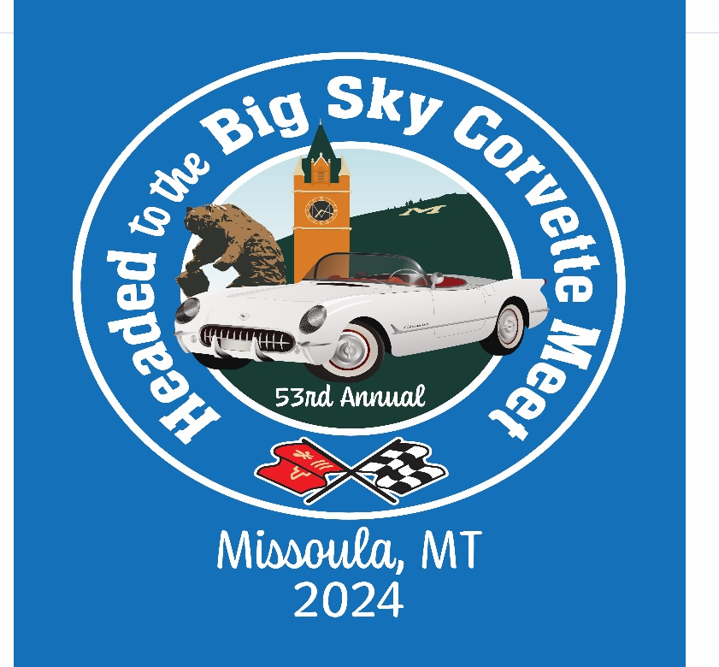
Registration Form – Big Sky Meet, May 24-27, 2024

Name: ___________________________________________________________________________

Spouse/Friend Full Name: ___________________________________________________________

Mailing Address: _________________________________________________________________________________
City: ____________________________State/Province: _________Zip/Postal Code: ___________

Phone Number: _________________________ email: __________________________________

Is this your first Big Sky Corvette Meet? Yes No

Any dietary restrictions? (we will do our best to accommodate) List: __________________________

Corvette Information:
Corvette Club Affiliation: __________________________________________
# of miles driven to Missoula__________
Year: ________ Coupe: ________ Convertible: ________ Color: _______________
If you are planning on bringing an additional Corvette, please complete this section.
Year: ________ Coupe: _________ Convertible: ________ Color: _______________

Registration Cost:

- Postmarked January 1-March 31 Single $160.00 Couple $270.00

- Postmarked April 1-May 4 Single $210.00 Couple $320.00

- Postmarked May 5-24 Single $325.00 Couple $545.00

Insurance liability waiver must be signed by all attendees at registration check-in, regardless of what events you do or do not participate in.

Lodging:
The host site for the 2024 State Meet is the Hilton Garden Inn located at: 3720 N Reserve St., Missoula MT 59808. Phone 406-532-5300. Room rates are $218 (includes all fees and taxes) per night for a double occupancy room. There are two other motels in close proximity that will honor the Hilton’s rate of $218. Links for room reservations: (CTRL + Click to follow link):

Hilton Garden Inn: 406-532-5300 (Reservation cutoff is April 24)

Book Room at Hilton Garden Inn for the Big Sky Meet 2024

Courtyard by Marriott: 406-549-5260 (Reservation cutoff is April 24)

Book Room at Courtyard by Marriott for the Big Sky Meet 2024

TownPlace Suites by Marriott: 406-721-6000 (Reservation cutoff is May 10):

Book Room at TownPlace Suites by Marriott for the Big Sky Meet 2024

Reminder – you need to register for the Meet along with making room reservations!

See page 7 for other motels in the area.

Activities:

Friday: Registration at Hilton Garden Inn. 3:00 pm to 7:00 pm.

Mix and mingle – pizza and beverages. 5:00 pm to 9:00 pm Missoula Chevrolet (formerly
Karl Tyler Chevrolet), 3757 N Reserve St.

5:00 pm – 9:00 pm -Tech for autocross at Missoula Chevrolet.

Saturday: All activities for Saturday (except the rally) will originate from the Missoula County
Fairgrounds.

Late Registration - 8:00 am to 10:00 am

Tech for the autocross will be available until 12:00 noon.

A continental breakfast will be available at the Home and Arts Building at the Fairgrounds
hosted by the Missoula Taekwondo Booster Club. Cost will be by donation.

7:00 am - We are excited to announce we will be spelling out the word “CORVETTE” using
cars registered for the Meet, 100% participation is requested. We will have a drone taking
pictures and video. More information will be available in your registration packet.

Cars will remain in place for the show and shine. This event is going to be open to the
public so for safety concerns we will not allow a car to be moved once it is in place
until the show is over, unless it’s an absolute emergency.

Food trucks will be available to grab a quick lunch before heading out for the afternoon.

Rally will depart from the Hilton and fun run will depart from the Fairgrounds.

Dinner will be at the Fairgrounds, happy hour 5:00, dinner at 6:00

Sunday: 8:00 am - Autocross – Missoula Chevrolet

Fun runs for the day will leave from the Hilton Garden Inn. Times to be determined.

Dinner at the Hilton Garden Inn, happy hour 5:00, dinner at 6:00. Awards to follow.

Monday: For those who would like to stick around for a little while longer, all Corvettes have been
invited to the Memorial Day Parade in Corvallis, Montana that begins at 10:00 am.

Activities: I/we plan to participate in (Please select):

Show and Shine – Class (C1-C8) __________ Include all cars you bring

Autocross – Number of drivers: (F)____ (M)____ Class ___________________

C1 – 1953-1962 | C2 – 1963-1967 | C3 – 1968-1982
C4 – 1984-1996 | C5 – 1997-2004 | C6 – 2005-2013
C7 – 2014-2019 | Z06/ZR1 | Race Prepared/Modified
C8 – 2020-2024 | EV

Autocross Regulations: Snell 2010 or newer helmets required. If you plan to Autocross, be sure to make time to get your car teched on Friday evening or Saturday morning until 12:00, as all participants must be ready to go by 8 a.m. sharp Sunday morning. NO TECHING AVAILABLE ON SUNDAY.

Sign-up for the fun runs will be available at time of registration. Number or participants may
may be limited due to capacity of parking and lunch facility. We may have additional activities available at time of registration.

Order merchandise on page 5. Be sure to include page 5 with your registration if you order merchandise.

TOTAL AMOUNT OF YOUR PAYMENT IS $______________ (include registration and merchandise)

Mail Registration Form and Payment To: Hellgate Corvette Club, PO Box 2404, Missoula, MT 59806

Contact Information: Don Matlock 406-369-0706, Murray Elliott 509-979-5380,
Ron Benton 406-370-3181, Larry Jones 406-544-6074, Linda Benton 406-544-5317,
Cathy Smyers 406-214-4688

Merchandise:
All clothing is Royal Blue in color and the t-shirt has no pocket. Polo shirts, fleece jackets, and sweatshirts will have the Meet logo embroidered on them. Women’s and men’s sizes available in t-shirts, fleece jackets and polo shirts; one style only in the sweatshirt. See page 6 for samples of merchandise.
Enter quantity desired on line:

Polo Shirt: S-XL $27.00, 2XL $29.00, 3XL $31.00
WOMEN - Size __________ MEN - Size __________

Short Sleeved T-Shirt: S-XL $15.00, 2XL $17.00, 3XL $19.00
WOMEN - Size __________ MEN - Size __________

Sweatshirt: S-XL $34.00, 2XL $36.00, 3XL $38.00
Size: ______________

Soft Brushed Canvas Cap: $19.00 Quantity: _________

Ladies Action Visor: $16.00 Quantity: _________

The following items must be ordered – they will not be for sale at the Meet:

Compact Umbrella: $12.00 Quantity: _________

Travel Blanket: $29.00 Quantity: __________

Fleece Jacket: S-XL $38.00 2XL $40.00 3XL $42.00
WOMEN – Size ___________ MEN – Size __________

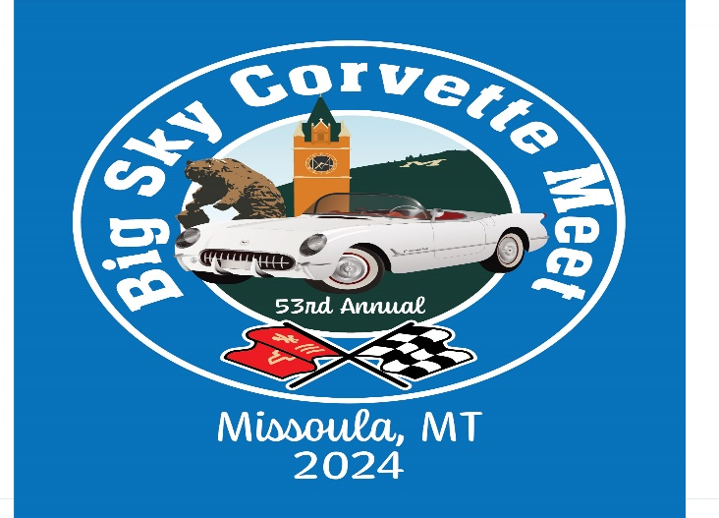
Sample of merchandise available
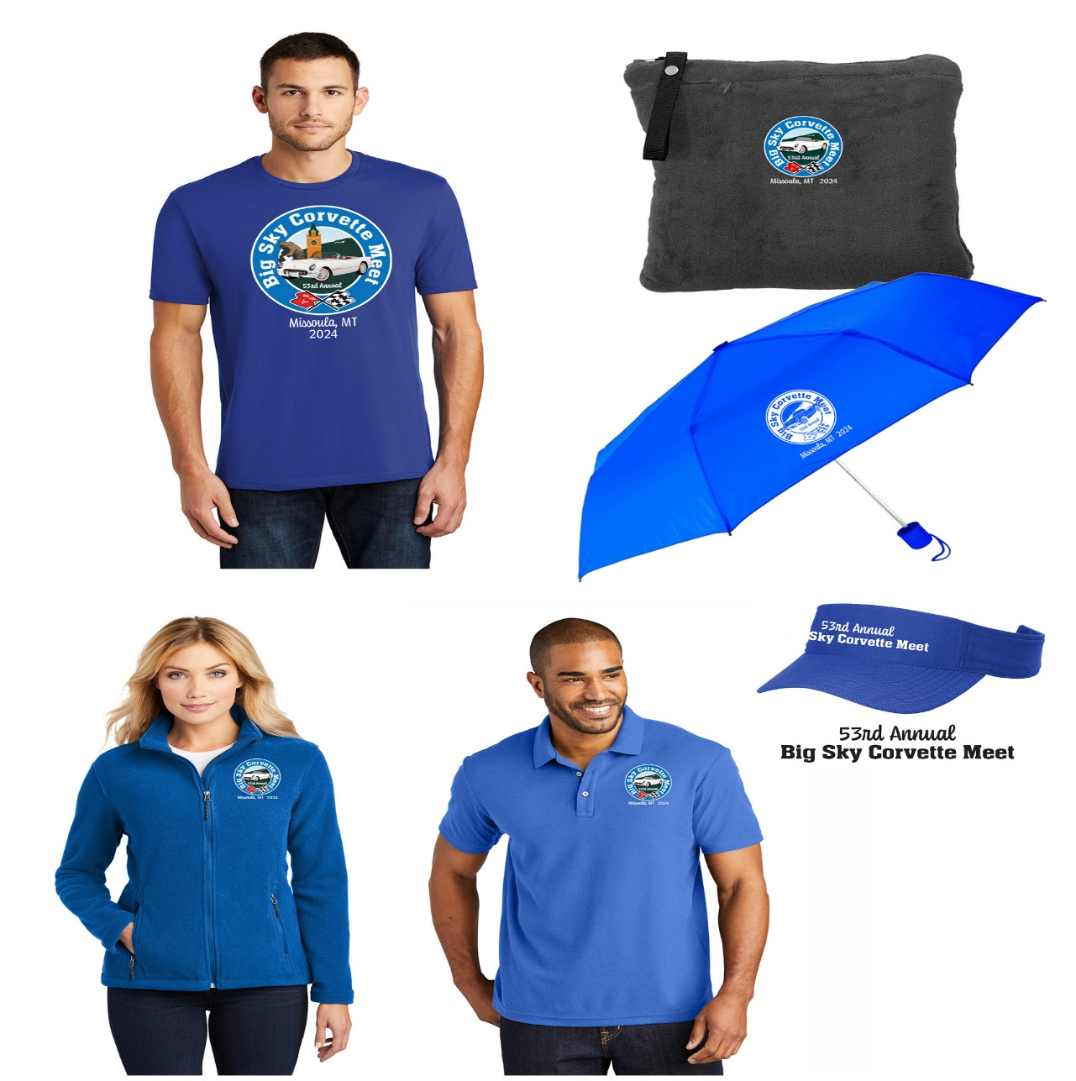

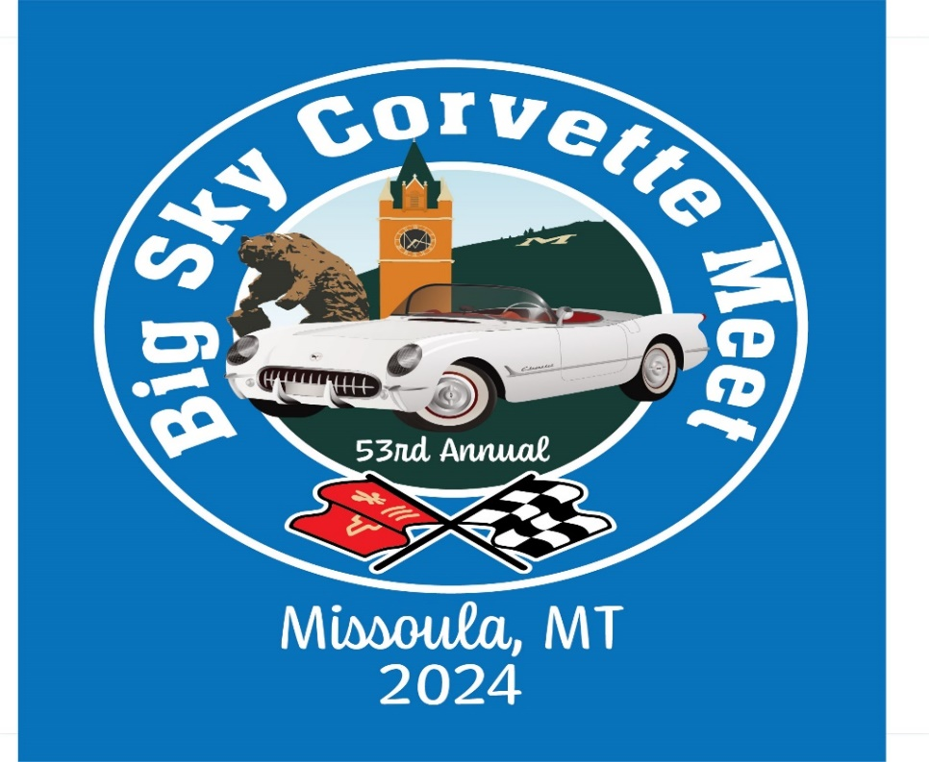

ADDITIONAL MOTELS IN CLOSE PROXIMITY TO THE HILTON GARDEN INN

Holiday Inn Express: 150 Expressway 406-830-3100

Staybridge Suites: 120 Expressway 406-830-3900

Quality Inn and Suites: 4545 N. Reserve 406-542-0888

Super 8 Motel: 4703 N. Reserve 406-549-1199

Hampton Inn: 4805 N. Reserve 406-549-1800

